# Probability and Statistics for Seismology and Structural Reliability (CENGM0078)

**Coursework Assignment**

**Student Number: 2041710**

The total length of the coursework assignment is to be no more than **8 pages** including references**.**

## 1. INTRODUCTION

Please follow this template and do not change the font size, margins, header, etc. of the template. Start typing your paper in this font in this way. Section headings are to be in 10pt bold and full caps. Number the headings consecutively or, in accordance with any question numbering in the coursework assignment instructions. Leave a single blank line before each Section Heading and one blank line between the heading and the first line of text. The first paragraph of each section should be formatted like this paragraph (i.e. with no indentation in the first line). For each subsequent paragraph in the section just press ‘return’ to go to the next line, and then press ‘tab’ once to indent the paragraph (see below). Do NOT change the spacing ‘before’ and ‘after’ the paragraph to try and squeeze more in.

This is now a new paragraph which starts with a tab space. When you are starting new sentences you must put a space after the full stop. Just like this. Text should be single spaced, left and right justified. The page size must be A4 with a 25.4mm margins on the left, right, top and bottom of the page. You must use Times New Roman with a font size of 10pt. Tables and direct quotes have a smaller font size as shown below.

## 1.1 Secondary Heading or Sub-headings

Here we have a sub-heading. There is no blank line after the sub-heading, however, the line spacing is 6pt after the sub-heading (you can see this in the ‘Paragraph’ options under the ‘Home’ tab). You can have one level of subheadings but not a third i.e. you cannot have 1.1.1 as a subheading.

## If you want to list bullet points you can do so;

## This is the second point;

## This is a third bullet point;

## A fourth bullet point;

After a list you must leave a single blank line and remember to add the indent if you are starting a new paragraph.

## 1.2 Another sub-heading

You can have as many sub-headings in a section as you want to. Note that sub-headings have a 6pt spacing after them rather than a blank line, but they are preceded by a blank line.

## 2. SECTION HEADING

## 2.1 A sub-heading in a different section

We want you to use the Harvard referencing system so let us try it out. I want to cite Norman et al.’s paper which was published in 2006. Norman et al. (2006, p24) state that “our integrated approach to research has enabled us to design, construct and accurately control the first dedicated multiple support excitation experimental test bed ...”. Note that we include a page number for direct quotes, but if we have paraphrased a source in our own words, we do not need to give the page number. Some of us like to include a formula or two and these should be referred to in the text in the form equation 1.

$x=\frac{-b±\sqrt{b^{2}-4ac}}{2a}$ 1.

where, *x* is a number; *a*, *b*, and *c* are other numbers.

$BCP=176R+28G+46B$ 2.

where, *BCP, R, G* and *B* are also useful numbers.

Figure 1 shows a graph. Figures / diagrams / photos are to be centred, with the reference and caption printed below the figure. The lettering used in the illustrations should be easily legible. Illustrations are to be referred to as figures and must be quoted in the text. One blank line should be left between the figure caption and the next paragraph. Please ensure that all figures are of the highest quality. Keep figures as simple as possible. Avoid excessive notes. Photographs must have a resolution of at least 300 dpi. The use of colour is allowed on figures. Note that the text does not wrap around the figure but if you do not like the wasted space then it is acceptable to put two figures side by side but they must be e.g. a ‘Figure 1(a)’ and ‘Figure 1(b)’ and not ‘Figure 1’ and ‘Figure 2’. See the example given as Figure 2. However, all figures must be as close as possible to the location where they are first referred to in the text. The figure should not be surrounded by an unnecessary box/border. Use the ‘crop’ option to remove any such boxes or borders when inserting figures from MS Excel.

If you want to quote from a source directly please make sure you enclose the words as shown. Norman et al. (2006, p24) explain how “experimental research is also enabling us to validate numerical methods through comparison of results with experimental tests”. However, if you want to quote a large block of text then it needs to be in font size 8 and indented (1cm on each side) as shown below. Norman et al. (2006, p24) give the following description of BLADE:

“…with the recent opening of BLADE (Bristol laboratories for advanced dynamic engineering) the scope for real-time large-scale testing has greatly increased. Our integrated approach to research has enabled us to design, construct and accurately control the first dedicated multiple support excitation experimental test bed for testing scale models of long span bridges. This test bed is being used to help increase our understanding of the effects of MSE on structures.”

Now we return to the rest of the text. Finally, make sure you leave a line below the paragraph before a figure and then insert the figure as shown below.

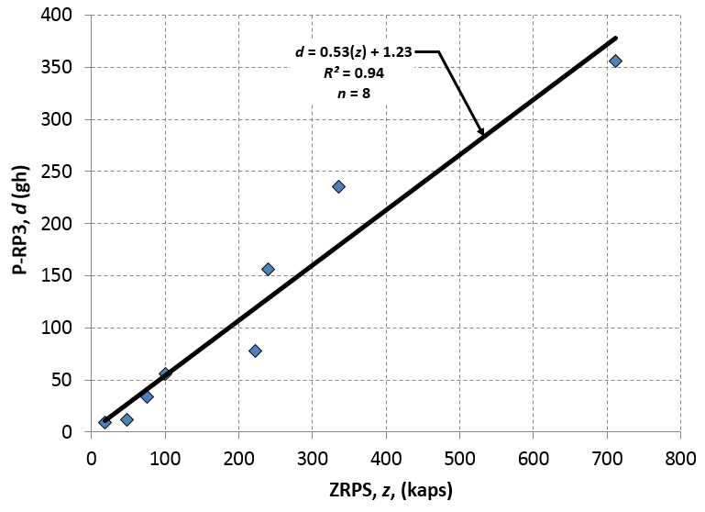

**Figure 1: An interesting plot (note that figure captions go BELOW THE FIGURE)**

Leave a single blank line then simply re-start typing a new paragraph after the figure.

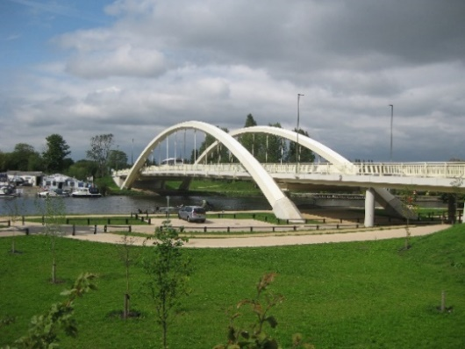**(a) 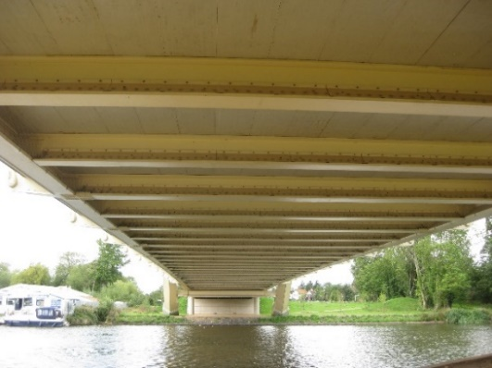(b)**

**Figure 2: Walton-on-Thames Bridge (a) wide shot and (b) the underside of the deck**

**(photos taken by P. J. Vardanega, used with permision)**

## 3. NEXT HEADING

Table 1 contains something interesting. For tables make sure that you use 8-point Times New Roman for ALL the text in the table (apart from the caption). Please be consistent throughout your manuscript. Leave one blank line before the table title, another blank line after the title and one blank line after the table. Table titles must be above the table. As with figures the use of color is acceptable in tables. Make sure that the table does not run across multiple pages. If it does then have a repeat of the table caption with the word ‘continued’ in brackets after it.

**Table 1: Summary of the database (note that table captions go ABOVE THE TABLE)**

|  |  |  |
| --- | --- | --- |
| **Column heading** | **Column heading** | **Column heading** |
| Table Text | 10 | Falling head permeameter |
|  |  |  |
| Concrete | 2 | Strong |
| Steel | 1 | Stronger |
| Timber | 3 | Weak |

## 4. SUMMARY

The conclusions to be drawn from this work are as follows:

* This is a great template

## REFERENCES

Anglia Ruskin University, (2017). *Guide to the Harvard Style of Referencing*, [online]. See: < https://libweb.anglia.ac.uk/referencing/files/Harvard_referencing_201718.pdf > (accessed 19/10/2017)

Bhattacharjee S and Mallick RB (2002) An alternative approach for the determination of bulk specific gravity and permeability of hot mix asphalt (HMA). International Journal of Pavement Engineering **3(3):** 143-152, <http://dx.doi.org/10.1080/1029843021000067782>

Brown ER, Hainin MR, Cooley A and Hurley G (2004) Relationships of HMA In-Place Air Voids, Lift Thickness, and Permeability Volume 1. Report: NCHRP web document 68 (Project 9-27), available from: < [www.trb.org/publications/nchrp/nchrp_w68v1.pdf](http://www.trb.org/publications/nchrp/nchrp_w68v1.pdf) >(accessed 11/10/2015)

Catbas FN, Kijewski-Correa T and Aktan AE (eds.) (2012) *Structural Identification of Constructed Facilities: Approaches, Methods, and Technologies for Effective Practice of St-Id. American Society of Civil Engineers*. American Society of Civil Engineers, Reston, Virginia, United States of America.

Ebrahimian H and De Risi R (2014) Seismic Reliability Assessment, Alternative Methods for. In *Encylopedia of Earthquake Engineering* (Beer, M., Kougioutzoglou, I. A., Patelli, E. and Au I. S.-K. eds.), Springer Berlin Heidelberg, <http://dx.doi.org/10.1007/978-3-642-36197-5_245-1>

Norman, J. A., Virden, D. W., Crewe, A. J. and Wagg, D. J. (2006). Modelling of bridges subject to multiple support excitation. The Structural Engineer **85(5):** 24-26.

Polshin DE and Tokar RA (1957) Maximum, Allowable Non-Uniform Settlement of Structures. In *Proceedings of the Fourth International Conference on Soil Mechanics and Foundation Engineering: London 12-24 August 1957*. Butterworths Scientific Publishing, London, United Kingdom, vol. 1, pp. 402-405.

Smith WF and Hashemi J (2011) *Foundations of materials science and engineering*, 5th SI edition, McGraw-Hill, London, United Kingdom.

***Your ENTIRE coursework document should be no more than 8 pages including the reference list. Please check you have complied with this page limit, and that you have used the font sizes and spacings specified in this template, else a penalty will be applied.***

***Remember you need to submit your coursework document as a PDF document. When you convert your document into PDF make sure you check that all the fonts, figures and text have been preserved in the layout you intend.***

***Guidance notes for referencing:***

We will generally follow the guidelines for referencing from ICE Publishing.

ICE (2015). Guidelines for referencing - Engineering journal titles, [online]. See <http://www.icevirtuallibrary.com/page/authors/preparing-your-manuscript/guidelines-engineering/harvard-referencing> (last accessed: 31/03/2020)

Please list all your references in **alphabetical order**, not the order they appear in the paper. The reference section heading is not numbered. Do not set the paragraph formatting to ‘justify’ for the references, leave it at left aligned. Set the paragraph formatting to ‘hanging’ with a 0.75 cm indent as shown below. The font size is reduced as shown in the example list at the back to 8pt. Some example references are provided below:

**Example citation of books:**

Smith WF and Hashemi J (2011) *Foundations of materials science and engineering*, 5th SI edition, McGraw-Hill, London, United Kingdom.

The next citation example is for a book which was ‘edited’ but each chapter has different authors (see how eds. is given before the year):

Catbas FN, Kijewski-Correa T and Aktan AE (eds.) (2012) *Structural Identification of Constructed Facilities: Approaches, Methods, and Technologies for Effective Practice of St-Id. American Society of Civil Engineers*. American Society of Civil Engineers, Reston, Virginia, United States of America.

This is a citation of a specific chapter from a book which has different authors to the editors of the book (note how we keep the title of the entire book in italics, since the book that this chapter is in is not in print no page range is given. Sometimes book chapters also have a doi which should be listed as for journal articles (see below):

Ebrahimian H and De Risi R (2014) Seismic Reliability Assessment, Alternative Methods for. In *Encylopedia of Earthquake Engineering* (Beer, M., Kougioutzoglou, I. A., Patelli, E. and Au I. S.-K. eds.), Springer Berlin Heidelberg, <http://dx.doi.org/10.1007/978-3-642-36197-5_245-1>

**Example citation of a journal article:**

Bhattacharjee S and Mallick RB (2002) An alternative approach for the determination of bulk specific gravity and permeability of hot mix asphalt (HMA). International Journal of Pavement Engineering **3(3):** 143-152, <http://dx.doi.org/10.1080/1029843021000067782>

Norman, J. A., Virden, D. W., Crewe, A. J. and Wagg, D. J. (2006). Modelling of bridges subject to multiple support excitation. The Structural Engineer **85(5):** 24-26.

Note that we put the issue number in brackets after the volume number and we put the volume and issue number in bold as shown before showing the page range. If available please put the doi number in as shown. Some publishers have now dispensed with issue numbers and some have dispensed with page numbers, replacing them with article numbers. See the next example:

Cantero D and González A (2014) Bridge damage detection using weigh-in-motion technology. Journal of Bridge Engineering **ASCE 20(5):** 04014078, h[ttp://dx.doi.org/10.1061/(ASCE)BE.1943-5592.0000674](http://dx.doi.org/10.1061/(ASCE)BE.1943-5592.0000674)

**Example citation of a conference paper published in printed proceedings:**

Polshin DE and Tokar RA (1957) Maximum, Allowable Non-Uniform Settlement of Structures. In *Proceedings of the Fourth International Conference on Soil Mechanics and Foundation Engineering: London 12-24 August 1957*. Butterworths Scientific Publishing, London, United Kingdom, vol. 1, pp. 402-405.

The article is to be found in the proceedings of the conference and the full title of the printed proceeding should be given and the volume number if available. Since it is technically a book extract you should give the publisher and location as shown. At the very end put the page range. Often conference proceedings will have editors and they should be included in the example below:

**Example of a report published on the web:**

Brown ER, Hainin MR, Cooley A and Hurley G (2004) Relationships of HMA In-Place Air Voids, Lift Thickness, and Permeability Volume 1. Report: NCHRP web document 68 (Project 9-27), available from: [www.trb.org/publications/nchrp/nchrp_w68v1.pdf](http://www.trb.org/publications/nchrp/nchrp_w68v1.pdf) (accessed 11/10/2015)

Note how we give the report number/identifier and we are careful to include the date the report was last accessed from the web.

**Example citation of a code of practice or standard:**

BSI (1990). BS 1377-2. Methods of test of soils for Civil Engineering purposes. Classification tests.British Standards Institute, London, United Kingdom.

**Example citation of web-links:**

Citation of web-pages should be avoided if possible, as information on web-links changes more frequently than we may think. This is why the accessed date is very important.

Anglia Ruskin University, (2017). *Guide to the Harvard Style of Referencing*, [online]. See: < https://libweb.anglia.ac.uk/referencing/files/Harvard_referencing_201718.pdf > (accessed 19/10/2017)

University of Bristol (2015a). *Faculty of Arts: A Guide to Referencing your Work: Harvard (author-date) referencing system*, [online]. See <http://www.bristol.ac.uk/arts/exercises/referencing/page_25.htm> (accessed 6/10/2015)

University of Bristol (2015b). *Engineering Student Handbook*, [online]. See <https://www.bris.ac.uk/engineering/currentstudents/handbooks/ughandbook/> (accessed 6/10/2015)

**Notes**

For more guidance on use of references, we will be using the University of Bristol, Faculty of Arts guidance on the Harvard (author-date) referencing system – a useful link is below:

<http://www.bristol.ac.uk/arts/exercises/referencing/page_25.htm> (accessed 6/10/2015)

You can also refer to the more comprehensive guidance from Anglia Ruskin University (2017) which covers how to reference more unusual materials such as interviews or software programs.

Anglia Ruskin University, (2017). *Guide to the Harvard Style of Referencing*, [online]. See: < https://libweb.anglia.ac.uk/referencing/files/Harvard_referencing_201718.pdf > (accessed 19/10/2017)